Merging single-cohort proteogenomic datasets is non-identifiable for cross-tumor contrasts: a calibrated benchmark in liver and kidney cancer

Abstract
Objective. Integrating single-cohort-per-condition multi-omics datasets across conditions is a common biomedical-informatics task, but when the biological contrast is perfectly aliased with cohort and batch the integration can be non-identifiable. Using the two largest open liver-cancer proteogenomic cohorts (one hepatocellular carcinoma [HCC], one intrahepatic cholangiocarcinoma [iCCA]) as a testbed, we ask what such merges can support and provide a reusable evaluation procedure.
Methods. Using only open data, we built an HCC-to-iCCA lineage axis from TCGA-LIHC (n=371) and TCGA-CHOL (n=35) RNA-seq (nested cross-validation, permutation, non-marker hold-out), tested whether the single-cohort Gao 2019 HCC and Dong 2022 iCCA proteome and phosphoproteome recover lineage biology against the batch-free RNA axis (non-aliased positive control, ComBat baselines, ground-truth titration, second-organ kidney pair), and probed DepMap dependency with the direct iCCA-vs-HCC contrast.
Results. The lineage axis was robust (nested cross-validated AUC 0.966). The single-cohort proteome and phosphoproteome did not recover lineage biology (proteome-versus-batch-free-axis rho = -0.15, harmonization-dependent); a non-aliased control showed the achievable ceiling is negligible (rho = 0.015). Naive harmonization flagged 63% of liver and 76% of kidney proteins as significant, none validating against the RNA anchor. ComBat could not rescue this: unprotected it erased the contrast, and protecting tumor type left a rank-deficient design implementations reject. A ground-truth titration calibrated how a standard anchor check degrades across aliasing regimes (pooled Spearman -0.68). An apparent iCCA-selective kinase program was a comparator artifact; only LAT1 amino-acid transport survived, aligned with a positive nanvuranlat phase-2 trial.
Conclusion. Single-cohort-per-condition proteogenomic merges are non-identifiable for the cross-condition contrast. We provide a reproducible non-identifiability benchmark and a ground-truth calibration of a standard anchor check, plus a vetted HCC-to-iCCA lineage axis; apparent condition-selective dependencies must be tested against the correct comparator.
Keywords: Data integration; Batch effects; Non-identifiability; Confounding; Proteogenomics; Reproducibility; Benchmarking

1. Introduction
Statement of Significance. Problem: Integrating single-cohort-per-condition multi-omics datasets across conditions is routine in biomedical informatics, but when the biological contrast of interest is perfectly aliased with cohort and batch the integration is non-identifiable, and a standard harmonization can manufacture large, plausible, but false differential lists. What is already known: Batch-free anchor and negative-control checks (removing unwanted variation, surrogate variable analysis, guided principal-component analysis, and the routine mRNA-protein concordance check) exist, but they are routinely omitted in the single-cohort-per-condition setting, and how they degrade under perfect aliasing has not been calibrated. What this paper adds: A formal non-identifiability framing for this integration design, a ground-truth calibration of how a standard anchor check degrades with the degree of aliasing, and a reproducible two-disease benchmark, demonstrated where the merge is most tempting (liver and kidney cancer proteogenomics).
A recurring task across biomedical informatics is to combine multi-omics datasets that were generated in separate cohorts, often one cohort per condition, into a single analysis. When the contrast of scientific interest is perfectly aliased with the cohort and its batch, no normalization can separate the biological signal from the technical one, and the contrast is non-identifiable. We study this general problem in the concrete instance where it is most tempting, the integration of single-cohort proteogenomic datasets of different tumor types, and we develop and calibrate an evaluation procedure that a practitioner can apply.
Hepatocellular carcinoma (HCC) and intrahepatic cholangiocarcinoma (iCCA) are the two dominant primary liver cancers, and combined hepatocellular-cholangiocarcinoma (cHCC-CCA) is a rare biphenotypic entity whose taxonomy was standardized only recently [14]. Single-cell and spatial work has reframed the HCC to iCCA distinction as a continuum of lineage states. That framing motivates an attractive program: harmonize the largest open liver proteogenomic cohorts into one protein-level and phosphosite-level manifold, find the kinases whose activity changes along the lineage axis, place cHCC-CCA on that axis, and validate candidate kinases as selective dependencies.
Two open resources make this tempting. Gao and colleagues characterized 159 HBV-related HCCs with paired proteome and phosphoproteome [1], and Dong and colleagues characterized an iCCA cohort with the same layers [2]. The two share thousands of proteins and phosphosites. A structural obstacle is rarely confronted, however: each tumor type is one cohort, processed in one laboratory with one mass-spectrometry reference, so tumor type is perfectly aliased with batch. For HCC the contrast is also aliased with HBV etiology, because the Gao cohort is HBV-related. Under perfect aliasing no statistical procedure can separate the biological contrast from the technical one. We are not aware of a published study that has merged these two specific cohorts across tumor type and reported the aliased structure as biology; the program is a tempting but, to our knowledge, uncommitted design, and indeed it was the initial direction of our own work. We therefore present this as a prospective cautionary benchmark, written before such an analysis is published rather than after. We also note that the enzyme set we use for kinase-activity inference (below) includes non-kinase signaling genes, so we treat “kinase-activity manifold” as the program’s own framing and label gene classes explicitly throughout.
We did not assume the manifold is recoverable; we tested it. We first established a lineage axis from a layer where batch is controlled by construction, namely TCGA-LIHC and TCGA-CHOL RNA-seq on the identical GDC pipeline, and validated it out of sample. We positioned an open cHCC-CCA cohort on it and replicated the result in a second, independent one. We then asked, with explicit uncertainty quantification and a non-aliased positive control, whether the single-cohort proteome and phosphoproteome recover the same lineage biology. Because they do not, for reasons of identifiability rather than choice of normalization, we used the one validation layer that is genuinely batch-controlled, DepMap CRISPR dependency on a single platform, to probe lineage-selective vulnerabilities with the correct comparator, and we report how little of an apparent positive result survives a fair test. The contribution is a worked demonstration that these merges are non-identifiable, a ground-truth calibration of how a standard anchor check degrades with aliasing, and a reproducible benchmark across two cancers, not a new method or a target map.

2. Related Work
Correcting for batch and other unwanted variation in high-throughput data is a mature area. Empirical-Bayes location-and-scale adjustment (ComBat) is the standard tool for removing a known batch factor [13]. When the unwanted variation is not fully known, control-gene and negative-control methods such as removing unwanted variation (RUV) [21], surrogate variable analysis [23], and guided principal-component analysis for detecting residual batch structure [22] are widely used. A complementary and routine safeguard in proteogenomics is to validate a cross-cohort molecular contrast against an orthogonal, batch-free layer, most commonly by checking mRNA-protein concordance [24]. The common thread is to distrust a contrast that does not validate against an independent reference. What these tools share is an assumption that the biological factor is, at least partly, separable from the batch factor. The single-cohort-per-condition design violates that assumption exactly: the factor of interest is perfectly aliased with batch, so correction is not merely difficult but non-identifiable. Our work does not propose a new corrector; it characterizes this regime and calibrates how the established batch-free anchor check behaves as aliasing approaches the perfect-confounding limit.

3. Methods

Data sources (all open, no controlled access)
HCC proteome and phosphoproteome (159 tumors; 6,478 proteins, 26,418 phosphosites) came from the Gao 2019 supplementary tables (raw at NODE OEP000321) [1]. iCCA came from Dong 2022 (raw at NODE OEP001105) [2]; the cohort comprises 262 patients, of which 214 have proteome and phosphoproteome and 255 have mRNA, and we used the 214 with proteome and phosphoproteome for kinase and proteome analyses. TCGA-LIHC (371 primary tumors) and TCGA-CHOL (35 primary tumors) STAR log2(TPM+1) and clinical data came from the UCSC Xena GDC hub [5]; we treat TCGA-CHOL as iCCA, noting it may include a minority of non-intrahepatic biliary cases. The cHCC-CCA cohort came from GEO GSE241466, a mixed series of 7 non-tumor, 5 HCC, 5 iCCA, and 8 intermediate-cell carcinoma samples; we used only the 8 i-CHC samples, identified from the series-matrix sample labels. For an independent cHCC-CCA replication we used GEO GSE231854 (25 cHCC-CCA and 56 HCC, RNA-seq), with labels from its series matrix. For a cross-organ generality test we used two single-cohort kidney proteomes from different laboratories, clear-cell RCC (Qu 2022; iProX IPX0001962000) and papillary RCC (Al Ahmad 2019; PRIDE PXD013523), with TCGA-KIRC and TCGA-KIRP RNA as the batch-free anchor. DepMap Public 24Q4 CRISPR (Chronos) and model metadata came from figshare [6,7]. Kinase-substrate relations came from OmniPath enzyme-substrate data, phosphorylation only (40,109 relations) [8,9]; we note that this enzyme universe includes non-kinase signaling genes such as adaptors, transporters, regulatory subunits, and pseudokinases, and we label gene classes explicitly rather than calling the whole set kinases.

Lineage axis: cross-validation, permutation, and non-marker control
TCGA Ensembl IDs were mapped to symbols (GENCODE v36) and collapsed by maximum; primary tumors were selected by barcode. On the 2,000 most variable genes (z-scored), a linear discriminant separated HCC from iCCA. Because an in-sample discriminant in a design with far more features than samples and a 371-versus-35 split separates trivially, we report a stratified 5-fold cross-validated AUC with a 200-fold label-permutation null. The cross-validation is fully nested: the 2,000-most-variable-gene selection (which is label-free) and the standardization are re-fit inside each training fold within a single pipeline, so the held-out fold informs neither the feature filter nor the scaler. We repeat the analysis after holding out the canonical hepatocyte and cholangiocyte marker panels to show the axis is not mere marker readout. For cross-dataset positioning we used a platform-robust single-sample score: within each sample, genes were percentile-ranked, and the score was the mean percentile of cholangiocyte markers (KRT19, KRT7, SOX9, EPCAM, CD24, SPP1, MUC1, CFTR, HNF1B, ANXA4, TACSTD2, CLDN4; we note SPP1 and CD24 are progenitor/secretory rather than strictly ductal markers) minus that of hepatocyte markers (ALB, APOA1, APOB, APOC3, TF, TTR, CYP3A4, HNF4A, FGA, FGB, FGG, SERPINC1, CPS1, ARG1). For i-CHC (n=8) we report Cliff’s delta effect sizes, exact Mann-Whitney P, and a bootstrap confidence interval for the median, and we note the dependence of the ordered-trend P on the large pure-lineage arms.

Identifiability test of the proteome and phosphoproteome, with a positive control
We did not treat unsupervised cohort separation as biology. We examined per-cohort z-scoring, which removes a between-cohort contrast by construction, and within-sample percentile normalization, which cancels the global reference offset. For each shared protein we computed the iCCA minus HCC direction and correlated it (Spearman, with a 1,000-fold bootstrap confidence interval) against the batch-free TCGA RNA direction; sign agreement on strongly directional genes (absolute RNA log2FC above 1) was assessed by a binomial test. As a non-aliased positive control, we computed the iCCA minus HCC direction in DepMap cell-line expression (HCC and iCCA lines sit in the same dataset, so tumor type is not aliased with cohort) and correlated it with the TCGA direction. Per-sample kinase activities were estimated by kinase-substrate enrichment (KSEA; per-sample z of at least 5 substrate sites) [10,11] in each cohort, and the cross-tumor difference was benchmarked against the RNA axis as above. To show the negative correlation is a property of the harmonization rather than a fixed biological anti-correlation, we computed the proteome iCCA minus HCC direction under four standard normalizations (raw mean-abundance difference, within-sample percentile, per-cohort z-score, and quantile-normalized merge) and correlated each with the batch-free RNA direction. To make the failure mode concrete, we also ran the pipeline a naive analyst would use: quantile normalization of the merged proteome, a per-protein iCCA versus HCC Mann-Whitney test with BH-FDR, and validation of the significant hits against the batch-free RNA direction. Because a competent analyst would reach for a dedicated batch corrector rather than naive normalization, we additionally ran ComBat [13] in two modes: with batch set to cohort and no protected covariate, and with tumor type protected as a biological covariate; we report the discriminant separability, the fraction of proteins called significant, and the batch-free anchor concordance for each. We then calibrated the anchor check with a ground-truth titration: using TCGA-LIHC expression as substrate, we spiked a known 200-gene signature into a synthetic biological contrast, added a synthetic batch effect to a synthetic cohort, swept the contrast-to-cohort aliasing across 11 levels from 0 to 1 (20 repeats per level), and at each level measured true-signal recall, the realized false-discovery proportion, and the concordance of the recovered effect with a separate noisy orthogonal anchor (the spiked truth plus independent noise and a modality scale, not the noise-free truth); we report the pooled rank correlation (220 points). Because the 220 points are 20 replicates nested within each of 11 aliasing levels, we accompany the pooled value with a level-block bootstrap that resamples the 11 levels (an honest interval under the clustering) and with the mean within-level rank correlation (the alpha-conditioned association), and we repeat under additive and multiplicative batch models. We emphasize that the noisy anchor is built from the same injected signal as the recovered effect, so the titration calibrates the sensitivity of a standard check across aliasing regimes, not an independence between two measurements. Finally, to test cross-organ generality, we ran the same naive harmonization and anchor validation on the kidney ccRCC versus pRCC proteome pair.

Cell-line dependency with the correct comparator
In DepMap 24Q4, lines were classified by OncotreeCode into HCC (n=24), iCCA/IHCH (n=31), combined HCC and CC (KMCH1, n=1), and other (n=1,122); the later cell-line expression comparison (Figure 5B) used the 23 HCC and 30 iCCA lines that also have expression profiles. DepMap sample sizes therefore vary by data availability: the CRISPR dependency contrast uses 24 HCC and 31 iCCA lines, the line-expression comparisons use the 23 HCC and 30 iCCA lines with expression profiles, and program-level Chronos summaries use only lines with non-missing dependency values across the gene set. For each gene we computed selectivity versus all other lineages and the direct iCCA versus HCC contrast (Mann-Whitney with Benjamini-Hochberg FDR), and we annotated pan-lineage-essential genes (mean Chronos in other lineages below -0.5) and absolute essentiality (Chronos in iCCA lines below -0.5). TCGA differential expression used Mann-Whitney with BH-FDR. For the surviving signal we tested two gene programs, curated a priori from canonical pathway membership (iron handling; amino-acid transport) rather than derived from the contrast, at the program level by (i) a competitive permutation null (5,000 size-matched random gene sets) on the per-gene iCCA minus HCC dependency difference, (ii) a line-level Mann-Whitney of the per-line mean Chronos over the set (iCCA versus HCC lines), (iii) the same program’s coordinate expression in batch-free TCGA (CHOL versus LIHC), and (iv) the cross-line Spearman co-dependency structure. No multiplicity correction was applied across the small test family (two programs, four evidence legs each), so this analysis is exploratory. To quantify circularity, since two LAT1 genes are both in the program and among the selected genes, we repeated the dependency and expression tests after removing the discovery genes (SLC3A2, SLC7A5). Analyses used Python 3.13 (numpy, pandas, scipy, scikit-learn, statsmodels) and decoupleR with OmniPath [12]; no GPU was used. All scripts and intermediate tables are released.

4. Results

The HCC and iCCA lineage axis is robust and is not a marker artifact, and i-CHC is consistent with an intermediate phenotype
An in-sample discriminant separated HCC and iCCA almost perfectly (AUC 0.99985), but this is expected in a design with far more features than samples and is not used as evidence. Out of sample the lineage axis remained strong: the nested 5-fold cross-validated AUC was 0.966 (permutation null 95th percentile 0.629; permutation P below 0.005), and 0.966 when the canonical marker panels were held out, so the separation reflects broad transcriptomic lineage structure rather than a definitional readout of a few markers, and it is not an artifact of selecting features before cross-validation (Figure 1).
On the platform-robust single-sample score, i-CHC (n=8) fell between HCC and iCCA (medians -0.165, -0.082, +0.126; bootstrap CI for the i-CHC median -0.21 to 0.00). It was strongly separated from iCCA (Cliff’s delta = -0.86, P = 2.3e-5) and modestly from HCC (delta = 0.41, P = 0.045). The limits matter. The ordered-trend statistic (P = 4e-23) is dominated by the large, perfectly separated pure-lineage arms and does not by itself establish i-CHC intermediacy. The i-CHC versus HCC contrast rests on 8 samples and a marginal P. An earlier analysis that mistakenly included the cohort’s non-i-CHC samples flattened the result toward HCC, and correcting the cohort label changed the conclusion, which shows the fragility of small-sample cross-dataset positioning. We therefore frame i-CHC as consistent with an intermediate transcriptomic phenotype. An independent cohort supports the direction of this result: in GSE231854 (25 cHCC-CCA and 56 HCC, a separate study), cHCC-CCA was significantly shifted toward the cholangiocyte pole relative to HCC (Cliff’s delta = 0.58, one-sided P = 1.7e-5; Figure 5A). GSE231854 contains no pure-iCCA arm, so it replicates only the cholangiocyte-ward shift relative to HCC, not the full intermediacy. The intermediacy between both poles therefore rests on the primary 8-sample i-CHC cohort, which alone spans HCC and iCCA, while GSE231854 confirms the HCC versus cHCC-CCA direction in a larger, independent sample.

Single-cohort proteome and phosphoproteome do not recover lineage biology, an identifiability result
The two open proteogenomic cohorts share 6,067 proteins and 14,246 phosphosites, which superficially licenses a manifold. They do not support one. Per-cohort z-scoring removed the lineage-marker contrast (marker-score discriminant AUC 0.50), the arithmetic consequence of normalizing away a mean shift that is wholly between-cohort; a fully multivariate classifier still separates the cohorts after the same z-scoring (cross-validated AUC 0.975), but that residual separability is the batch artifact we decline to read as biology rather than recovered lineage signal. Within-sample percentile normalization, which preserves internal ordering, yielded a proteome iCCA minus HCC direction that was significantly discordant with the batch-free RNA direction (Spearman rho = -0.15, 95% CI -0.18 to -0.13; sign agreement 42%, binomial P = 2e-12; Figure 2). The phosphoproteome was uninformative: per-sample KSEA scored 237 kinases in both cohorts and flagged 134 with nominally significant cross-tumor activity differences, but these carried no lineage information (rho = -0.045; sign agreement 45%, binomial P = 0.17).
A non-aliased positive control calibrates how much concordance is even achievable. The iCCA minus HCC direction in DepMap cell-line expression, where HCC and iCCA lines sit in the same dataset so tumor type is not aliased with cohort, correlated with the TCGA direction only weakly, although significantly given the gene count (rho = 0.015, P = 0.041, n = 19,193). The effect is negligible even when significant, so the achievable ceiling for per-gene cross-dataset direction concordance sits far below any useful threshold, and a near-zero proteome correlation would have been uninformative by construction. We do not over-read this. The observed proteome correlation is not near zero but mildly negative (rho = -0.15), which the low ceiling alone does not fully explain. Rather than attribute the sign to a specific mechanism, we show it is harmonization-dependent: across four standard normalizations the proteome-versus-RNA direction concordance ranged from rho = -0.21 (raw mean-abundance difference) through -0.15 (within-sample percentile) and -0.13 (quantile-merge) to -0.004 (per-cohort z-score). The sign and magnitude therefore move with the normalization choice and are not a fixed biological anti-correlation; given the near-zero achievable ceiling, the small negative value is within ordinary cross-modality (RNA-protein) discordance and is best read as harmonization-dependent and uninterpretable as biology. The defensible conclusion is that these data cannot support a trustworthy cross-tumor axis, because the achievable signal sits below the noise floor of aliasing.
To make this failure concrete rather than abstract, we ran the pipeline a naive analyst would use. Standard quantile harmonization of the merged Gao-HCC and Dong-iCCA proteome, followed by a per-protein iCCA versus HCC test, flagged 3,796 of 6,067 proteins (63%) as significant at FDR below 0.05, among them 407 named signaling enzymes (for example PHKG2, PRKAR2B, COMT). This is the plausible, publishable hit list that the manifold ambition would generate. Yet these significant hits did not validate against the batch-free RNA axis: their harmonized direction was discordant with the TCGA direction (Spearman rho = -0.15, P = 2e-19; sign agreement 40%). A standard harmonization therefore does not merely fail to find signal; it manufactures thousands of plausible false positives, named kinases among them, that a batch-free check exposes as artifacts. A dedicated batch corrector does not escape the trap, as the identifiability argument predicts. Running ComBat with batch set to cohort and no protected covariate erased the contrast entirely (discriminant AUC 0.50, no proteins significant, anchor concordance rho = -0.13), exactly like per-cohort z-scoring, because the only between-cohort signal it can remove is the tumor-type contrast itself. Asking ComBat instead to protect tumor type as a biological covariate is ill-posed under perfect aliasing: the design matrix that pairs the cohort batch with the tumor-type covariate is rank-deficient (rank 2 of 3 columns), which is exactly the configuration the confounded-design guards in standard implementations (sva and pyComBat) reject. Forcing a solution through the pseudo-inverse yields a degenerate result that does not recover the batch-free axis: the cohorts no longer separate (discriminant AUC 0.51, 2% of proteins significant), yet the forced solution’s direction shows a spuriously positive anchor concordance (Spearman rho = +0.18 against the batch-free RNA axis, higher than any honest normalization and far above the +0.015 achievable ceiling). This is not recovered biology but the protected covariate being re-imprinted: protecting a covariate that is perfectly aliased with batch forces ComBat to re-inject the tumor-type contrast it was meant to preserve, manufacturing apparent concordance that is the aliased artifact itself, exactly the failure the identifiability framing predicts. The tool’s own confounding guard thus operationalizes the non-identifiability. This is the empirical content of the identifiability claim, and the reason we route every cross-tumor direction through a batch-controlled layer. A cross-tumor proteogenomic kinase-activity manifold built across these cohorts would report this aliased structure as biology.

Calibrating a standard anchor check for the single-cohort setting
The remedy for the problem is a long-standing idea, not a new one: validate a cross-cohort contrast against an independent batch-free reference and distrust low concordance. This is the principle behind negative-control and orthogonal-validation methods such as RUV [21], guided principal-component analysis [22], surrogate-variable analysis [23], and the routine mRNA-protein concordance check used throughout proteogenomics, including the Gao and Dong cohorts themselves [24]. Our contribution is not the check but a ground-truth calibration of how it degrades with aliasing in the single-cohort-per-type setting, where the check is usually skipped. Using real TCGA-LIHC expression as the substrate, we spiked a known 200-gene differential signature into a synthetic biological contrast, added a synthetic batch effect to a synthetic cohort, and swept the aliasing of the contrast with the cohort across 11 levels from 0 to 1 (20 repeats per level). Critically, we read concordance not against the noise-free truth but against a separate, noisy orthogonal anchor (the spiked truth plus independent noise and a modality scale, with concordance to the truth of only about 0.20, mimicking the modest agreement of a different molecular layer such as RNA), so that the calibration mirrors the real setting where TCGA RNA is the anchor (Figure 6).
The behavior is consistent and robust. As aliasing rose, the true signal was not lost (recall stayed above 0.82, minimum 0.83 under the additive model) but was buried: the false-discovery proportion climbed from 0.06 to 0.93. The weak, noisy anchor tracked this across regimes. Pooling the 220 runs, anchor concordance predicted the false-discovery load at Spearman -0.68 (level-block bootstrap 95% CI -0.72 to -0.43), and the relationship held under a multiplicative batch model (-0.68). Two honesty points bound how this should be read. First, the per-level effect on the anchor is small in absolute terms: mean anchor concordance shifts only from 0.105 at no aliasing to 0.042 at full aliasing, so the pooled correlation reflects this trend across aliasing regimes rather than a steep per-level decline. Second, within a fixed aliasing level the anchor-versus-false-discovery association is essentially nil (mean within-level Spearman -0.02 additive, -0.07 multiplicative), and the noisy anchor is by construction the injected signal plus independent noise while the recovered effect estimates that same signal, so the two are not independent measurements. The titration therefore calibrates the sensitivity of a standard check to the aliasing regime; it does not claim the anchor independently scores each replicate. Because the anchor is nonetheless a noisy, separate-modality proxy (concordance to the truth only about 0.20), this still supports the actual real-data use, in which TCGA RNA plays the anchor role. We do not place the real cross-platform correlations on the simulation scale, since they are different statistics; we report only that the real liver concordance (rho = -0.15) and the kidney concordance below sit at or below the worst simulated regime, consistent with non-identifiability. The practical procedure that follows is the standard one, applied where it is usually omitted: before reporting any cross-cohort differential, establish the achievable ceiling with a non-aliased positive control, validate the direction against a batch-free anchor, and report the fraction of significant hits that survive. The phenomenon is not confined to liver cancer. In a second organ, naively harmonizing two single-cohort, different-lab kidney proteomes of clear-cell and papillary renal cell carcinoma flagged 6,642 of 8,787 proteins (76%) as significantly different, yet these hits were uncorrelated with the batch-free TCGA-KIRC versus KIRP RNA anchor (Spearman rho = 0.004). This kidney pair is an extreme case, a TMT cohort versus a label-free cohort at 232 versus 16 samples, so it shows the failure mode recurs in a second organ rather than providing a powered second calibration.

Apparent iCCA-selective dependencies are largely a comparator artifact, and only a small amino-acid-transport signal survives a fair test
A naive selectivity definition, lower Chronos in iCCA lines than in all other lineages, at first glance nominated 11 iCCA-selective kinase dependencies, of which 9 appeared iCCA-up in batch-free RNA, an apparently coherent receptor-tyrosine-kinase, MAPK, and amino-acid-transport program. This artifactual positive, a version of which was the headline of our own first draft, does not survive scrutiny. The all-other-lineages comparator is overwhelmingly non-liver, so it measures liver versus non-liver essentiality, not HCC versus iCCA specificity. Under the correct direct iCCA versus HCC contrast with FDR control, only 2 of the 11 survived (SLC3A2 and TRPM7); 7 were pan-lineage-essential (for example CDK1, with Chronos near -2.5 in both liver lineages), and 3 (GRB2, CCND1, CRKL) were flagged selective for both liver lineages, that is liver-essential rather than iCCA-specific. EGFR, the most clinically suggestive hit, was neither RNA-concordant by the prespecified threshold (log2FC 0.38, below 0.5) nor differentially essential between the liver lineages (raw Mann-Whitney P = 0.15, BH-FDR 0.63), and its absolute dependency was marginal (Chronos -0.56). Several genes in the apparent set are not kinases at all: SLC7A5 and SLC3A2 are the LAT1 transporter, GRB2 and CRKL are adaptors, CCND1 is a cyclin, PPP1R12A is a phosphatase subunit, and ILK is a pseudokinase, so the kinase framing is itself inaccurate.
The direct contrast (FDR below 0.1) independently flags four genes, TFRC (transferrin receptor), SLC3A2 (LAT1 amino-acid-transport subunit), TRPM7 (an ion-channel kinase), and NHEJ1, comprising the two retained from the all-other-lineage set (SLC3A2, TRPM7) plus TFRC and NHEJ1, which were not in it. Three of the four (TFRC, SLC3A2, and the channel-kinase TRPM7) point to nutrient and ion transport rather than the textbook RTK axis; NHEJ1, a DNA-repair factor, has no transport rationale and is most likely an incidental survivor, which itself argues for caution about reading a four-gene set as a program. We do not present these as validated targets (n = 31 versus 24; FDR 0.04 to 0.08; TFRC and TRPM7 are preferential but pan-essential). Separately, FGFR1 illustrates that expression is an unreliable dependency proxy: its mRNA is markedly iCCA-higher (log2FC +3.16) yet its dependency is higher in HCC lines. FGFR1 is not the actionable iCCA target; the clinically validated program is FGFR2 fusions and IDH1 mutations [4,15], neither captured by bulk mRNA or unselected DepMap lines.

A corroborated positive, amino-acid transport (LAT1), recovered by the comparator-correct pipeline
The one program-level signal that is corroborated, rather than dissolved, under further testing is amino-acid transport, though its legs differ in strength and in their independence from the gene selection, which we are careful to separate. We tested two pathway programs, curated a priori from canonical membership (iron handling; amino-acid transport) rather than derived from the contrast, at the program level (Figure 4); no formal multiplicity correction was applied across the programs and axes, so this analysis is exploratory hypothesis-generation. The iron-handling program did not generalize: it was not preferentially essential in iCCA lines (competitive permutation P = 0.14) and not coordinately expressed (batch-free TCGA P = 0.55), so the single-gene TFRC hit does not reflect a broader iron-addiction phenotype.
For the amino-acid-transport program, the three legs are not equally independent of the gene selection, and we weight them accordingly. The load-bearing, selection-independent evidence is expression: the program is strongly and coordinately over-expressed in iCCA tumors (TCGA-CHOL versus LIHC: median log2FC +0.79; 86% of genes iCCA-up; set-score P = 1.2e-10), and this survives removing the two discovery genes, because dropping SLC3A2 and SLC7A5 leaves P = 1.6e-10 with 83% of remaining genes iCCA-up, so it is not an artifact of the genes that defined the signal. The CRISPR-dependency leg, in contrast, is partly circular: SLC3A2 and SLC7A5 (the LAT1 subunits) were themselves among the selected genes, and the program’s apparent iCCA-preferential dependency (competitive permutation P = 0.0024) is carried by them, since removing both collapses it to P = 0.20 (set-mean delta Chronos -0.059 to -0.011); both the full-set and leave-out values now come from a single seeded run over a common background. The selection-independent dependency evidence is therefore only the marginal line-level test (Mann-Whitney P = 0.045 for the amino-acid-transport set; iCCA mean Chronos -0.23 versus HCC -0.17, both above the -0.5 essentiality floor), and the co-dependency evidence (TFRC and SLC3A2 are co-dependent, rho = 0.56, though the broader set is not, mean rho 0.11; Figure 4C) likewise shares genes with the selection. We thus rest the program-level claim on the selection-independent expression axis plus the clinical anchor, and present the lineage-preferential dependency as the study’s own, more modest observation rather than a strong addiction. The over-expression is a property of iCCA tumors rather than of iCCA cell lines: in DepMap line expression the amino-acid-transport program was not elevated in iCCA versus HCC lines (one-sided P = 0.35, on the 23 HCC and 30 iCCA lines with expression data; the effect was near zero and if anything slightly lower in iCCA; Figure 5B). We read this as tumor-level or differentiation-dependent biology that passaged lines lose, which is consistent with the clinical evidence that LAT1 marks patient tumors and outcomes rather than cell lines, and it explains why the dependency signal in lines is weak.
The clinical anchor is real and specific to the transporter our analysis flags. The LAT1 (SLC7A5/SLC3A2) inhibitor nanvuranlat (JPH203) improved progression-free survival in a randomized, placebo-controlled phase 2 trial in advanced biliary tract cancer (hazard ratio 0.56, 95% CI 0.34 to 0.90, P = 0.02) [16], and high LAT1 expression is an established poor-prognosis marker in biliary tract cancer [17,18]. We report LAT1 and amino-acid transport not as a novel discovery, since it is biologically and clinically established, but as the lineage-preferential dependency that our comparator-correct analysis correctly recovers even as it rejects the EGFR artifact, the constructive counterpart to the comparator caution. The honesty bounds remain: the dependency effect is modest and partly circular, the nanvuranlat result is a phase 2 PFS signal (not overall survival or phase 3) in biliary tract cancer broadly rather than iCCA exclusively, and the supporting ferroptosis and glutaminolysis strands (SLC7A11, GLS) are preclinical in cholangiocarcinoma. The over-expression is also measured in unadjusted bulk tumors: TCGA-LIHC is etiologically mixed and we did not adjust for tumor grade or proliferation, so part of the iCCA-versus-HCC amino-acid-transport differential could reflect those covariates rather than a clean lineage program. The same caveat applies to the lineage score itself, which will partly read out differentiation grade.

5. Discussion
We set out to test, rather than assume, whether open liver-cancer proteogenomic data support a cross-tumor kinase-activity manifold, and to define what they do support. Two contributions are robust. First, we provide a cross-validated, marker-independent HCC and iCCA lineage axis on which rare intermediate-cell cHCC-CCA is consistent with an intermediate phenotype, with the caveat that the primary cHCC-CCA evidence rests on eight RNA-only samples. Second, we provide a cautionary benchmark: when tumor type is perfectly aliased with cohort, the proteome and phosphoproteome cannot be combined into a trustworthy cross-tumor axis. This is a design-level non-identifiability problem, not a normalization problem. The non-aliased positive control is essential to that conclusion because weak per-gene cross-dataset concordance is common even without aliasing.
The functional-genomics result makes the same informatics point in a different layer: selectivity is only as meaningful as its comparator. Defining iCCA-selective against all other lineages produced a coherent-looking EGFR/GRB2/CRKL program that mostly evaporated under a direct iCCA versus HCC test, a common way to mistake pan-essential or lineage-general genes for tumor-type-specific dependencies. The comparator-correct procedure also recovers a constructive result: amino-acid transport (LAT1: SLC7A5/SLC3A2, with glutaminolysis and TFRC) is supported by selection-independent tumor expression and by the phase 2 nanvuranlat PFS signal [16]. Its iCCA-preferential CRISPR dependency remains modest and partly circular. The iron-handling program, despite a strong TFRC single-gene hit, did not survive as a program, reinforcing the need to test pathways rather than narrate them from single genes.
For practitioners the guidance is concrete: anchor every cross-tumor direction to a batch-free layer; treat single-cohort-per-type proteogenomic merges as non-identifiable for the between-type contrast and use them only for within-cohort biology; cross-validate supervised separations when features greatly outnumber samples; and define dependency selectivity against the biologically relevant comparator with multiple-testing control. The same trap appears in kidney (ccRCC versus pRCC), and the ground-truth calibration shows the anchor check degrades with aliasing across regimes. The anchor check itself is established practice [21,22,23,24]; the contribution here is the calibration, the non-identifiability framing for this single-cohort-per-type case, and a transparent benchmark in a powered liver case with a corroborating, unpowered kidney case. We frame this as a prospective caution: we know of no published study that has merged these specific cohorts across tumor type, and the benchmark is meant to forestall a tempting analysis rather than rebut a committed one.

5.1. Limitations
- Aliasing of tumor type with cohort, and with HBV etiology, is intrinsic to the open proteogenomic data and is the dominant limitation; a definitive proteogenomic axis would need a second independent cohort per tumor type, which is not openly available.
- The comparison groups are small. TCGA-CHOL (n=35) and i-CHC (n=8) are small; the i-CHC intermediacy is preliminary at n=8, though its direction replicated in an independent cohort (GSE231854; 25 cHCC-CCA versus 56 HCC). DepMap iCCA (n=31) versus HCC (n=24) limits the power of the direct contrast, and IHCH annotation may be impure.
- cHCC-CCA is RNA-only in open data; kinase activity cannot be measured there, and the intermediate-cell i-CHC subtype is a specific, uncommon morphology that may not represent the broader classical and stem-cell-subtype cHCC-CCA spectrum (the GSE231854 replication is unsubtyped).
- The exploratory iCCA-preferential set (TFRC, SLC3A2, TRPM7, NHEJ1) rests on four genes at FDR 0.04 to 0.08 and requires replication; it is a hypothesis, not a result. FDR reflects rank separation rather than effect magnitude, so NHEJ1 (delta Chronos -0.16, non-essential in both arms) should not be read at the same status as TFRC or SLC3A2.
- KSEA and the OmniPath network are biased toward well-studied genes, and cross-cohort KSEA additionally suffers differential phosphosite coverage.
- The lineage score and the LAT1 expression test are computed on unadjusted bulk tumors: TCGA-LIHC is etiologically mixed and we did not adjust for tumor grade or proliferation, so a portion of the iCCA-versus-HCC signal may track those covariates rather than lineage alone. The program-level transport analysis curates two gene sets a priori and applies no cross-program multiplicity correction, so it is exploratory hypothesis-generation, not confirmatory.

6. Conclusion
Open, batch-controlled transcriptomic data define a robust HCC and iCCA lineage axis and position intermediate-cell cHCC-CCA as consistent with an intermediate phenotype, while the full position between both poles still rests on eight primary RNA samples. Single-cohort proteome and phosphoproteome data cannot support a cross-tumor kinase-activity manifold because the contrast is non-identifiable under perfect aliasing. Apparent lineage-selective dependencies likewise require the correct comparator. Tested fairly, the LAT1 amino-acid-transport program remains a modest but clinically anchored positive result, whereas the larger kinase program dissolves. We release the pipeline as a reusable cautionary benchmark for liver-cancer multi-omics integration.

Data and code availability
All data are public (NODE OEP000321; NODE OEP001105; UCSC Xena GDC hub for TCGA-LIHC and TCGA-CHOL; GEO GSE241466; GEO GSE231854; iProX IPX0001962000; PRIDE PXD013523; TCGA-KIRC and TCGA-KIRP; DepMap 24Q4; OmniPath). The complete pipeline, intermediate matrices, per-gene tables, and figure scripts will be deposited in a public repository (Zenodo, with a DOI, and GitHub) at acceptance, and are available from the corresponding author meanwhile. The environment is Python 3.13 with numpy 2.4, pandas 2.3, scipy 1.18, scikit-learn 1.9, statsmodels 0.14, decoupleR 2.1.6, and omnipath 1.0.12; the OmniPath kinase-substrate snapshot used here returned 40,109 phosphorylation relations and 1,657 enzymes (retrieved 2026-06). A top-level script regenerates the stat files and Table 2.

Declarations
Ethics approval. Not applicable. The study used only public, previously published, de-identified or aggregate datasets; no new human or animal data were collected.
Competing interests. The author declares no competing interests.
Funding. No specific funding was received.
Author contributions. A.T.Q. is the sole author and conceived the study, built and ran the analysis pipeline, interpreted the results, and wrote the manuscript.
Use of AI tools. The author used an AI coding and writing assistant (Anthropic Claude) to help locate and download public datasets, write and debug the analysis code, draft and revise the text, and run an internal simulated peer review that guided the analysis. The author specified every analysis, confirmed that all reported statistics were produced by the released scripts, independently verified that all cited references are real and correctly attributed, and takes full responsibility for the content and conclusions.

Figure legends
Figure 1. A cross-validated, marker-independent HCC and iCCA lineage axis with cHCC-CCA positioned intermediate. Left: PCA of TCGA-LIHC (HCC, n=371) and TCGA-CHOL (iCCA, n=35) primary tumors (identical GDC pipeline); nested cross-validated AUC was 0.966 (0.966 with markers held out). Right: cholangiocyte minus hepatocyte single-sample score across HCC, intermediate-cell i-CHC (GSE241466, n=8) and iCCA; i-CHC is strongly separated from iCCA (delta = -0.86, P = 2.3e-5) and modestly from HCC (delta = 0.41, P = 0.045, with the bootstrap median CI touching zero), so the HCC-side separation is suggestive at n=8 rather than definitive.
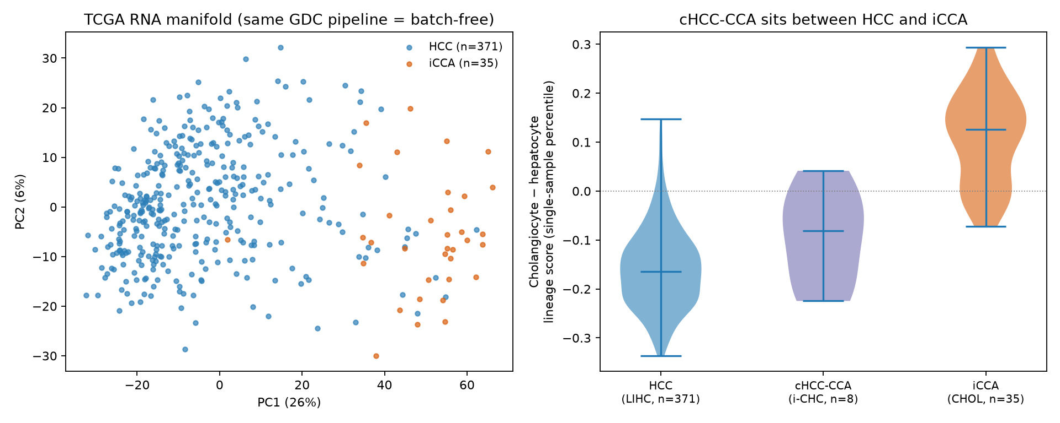
Figure 2. Single-cohort proteome data fail to recover the batch-free lineage axis. Left: PCA of within-sample-normalized Gao-HCC and Dong-iCCA proteomes; samples separate by cohort, which is perfectly aliased with tumor type. Right: per-protein iCCA minus HCC direction (proteome) versus batch-free TCGA RNA direction, which is significantly discordant (Spearman rho = -0.15, 95% CI -0.18 to -0.13).
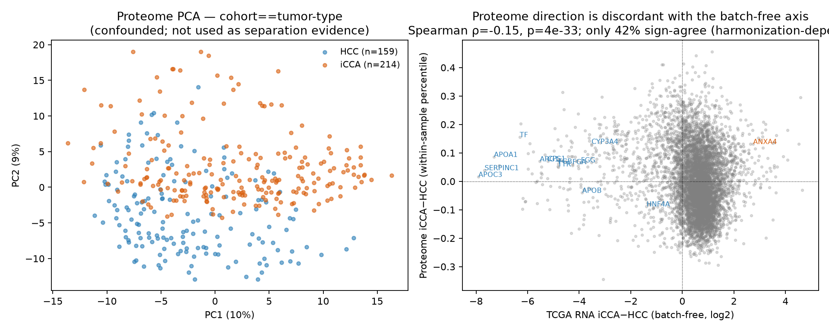
Figure 3. Apparent iCCA-selective dependencies and what survives a fair test. DepMap iCCA-selectivity versus all-other-lineages (left) nominates 11 hits, but the direct iCCA versus HCC contrast with FDR (right) leaves only TFRC, SLC3A2, TRPM7, NHEJ1; pan-essential and selective-for-both genes are flagged.
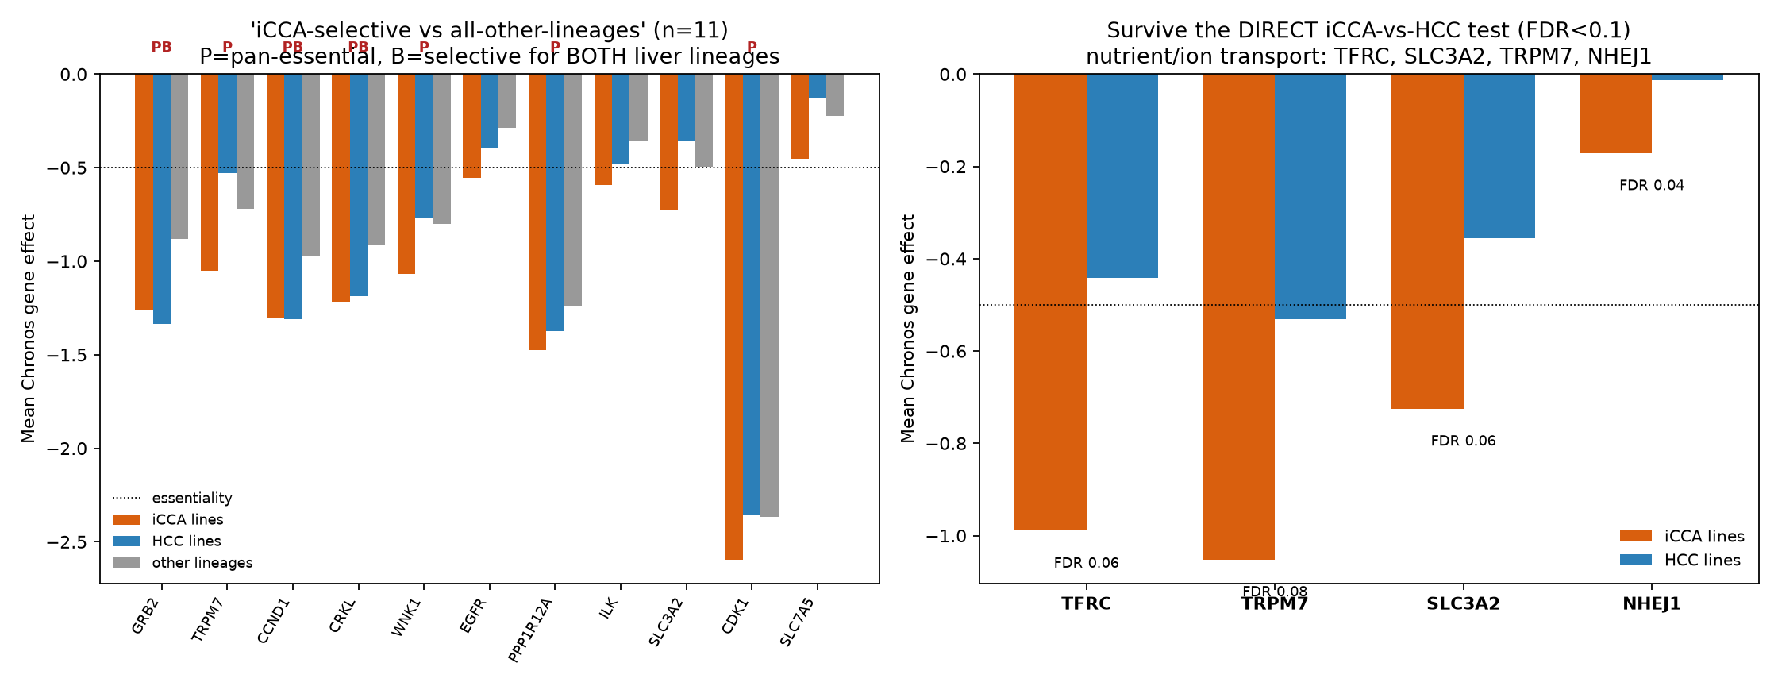
Figure 4. The amino-acid-transport (LAT1) program is preferentially essential and over-expressed in iCCA. Left: per-gene iCCA minus HCC dependency difference for the iron and amino-acid-transport genes (orange = more essential in iCCA); TFRC, SLC3A2, SLC7A5, GLS lead. Middle: program-level Chronos over the combined iron and amino-acid-transport set, iCCA versus HCC lines (combined set: line-level Mann-Whitney P = 0.096, competitive permutation P = 0.0020; amino-acid-transport set alone: Mann-Whitney P = 0.045, permutation P = 0.0024). The dependency permutation signal does not survive removing the LAT1 discovery genes SLC3A2 and SLC7A5 (P = 0.20), so it is partly circular; the batch-free expression corroboration does survive it (P = 1.6e-10, 83% of remaining genes iCCA-up). Right: cross-line co-dependency (Spearman) among iron and amino-acid-transport genes; TFRC and SLC3A2 are co-dependent (rho = 0.56), although the broader set is not coherently co-dependent (mean rho 0.11). The iron-handling program alone did not generalize (permutation P = 0.14; expression P = 0.55).
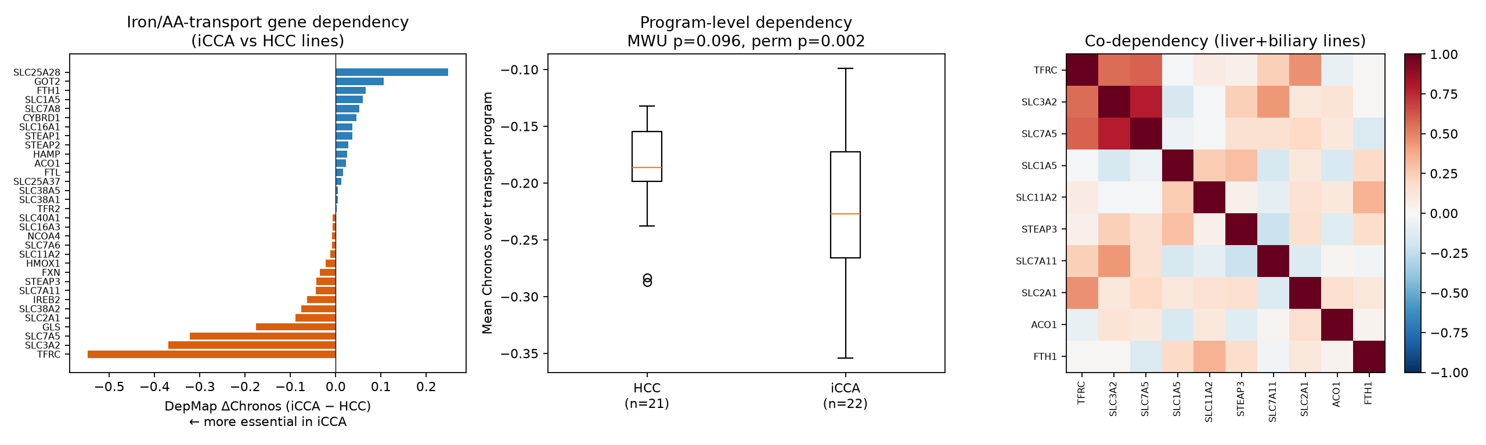
Figure 5. Independent replications. (A) In an independent cohort (GSE231854; 25 cHCC-CCA and 56 HCC), cHCC-CCA was significantly shifted toward the cholangiocyte pole relative to HCC on the single-sample lineage score (Cliff’s delta = 0.58, one-sided P = 1.7e-5), which replicates the direction of Figure 1. (B) In DepMap cell-line expression, the LAT1 and amino-acid-transport program was not elevated in iCCA versus HCC lines (one-sided P = 0.35), which indicates that the over-expression seen in tumors (Figure 4) is tumor-specific.
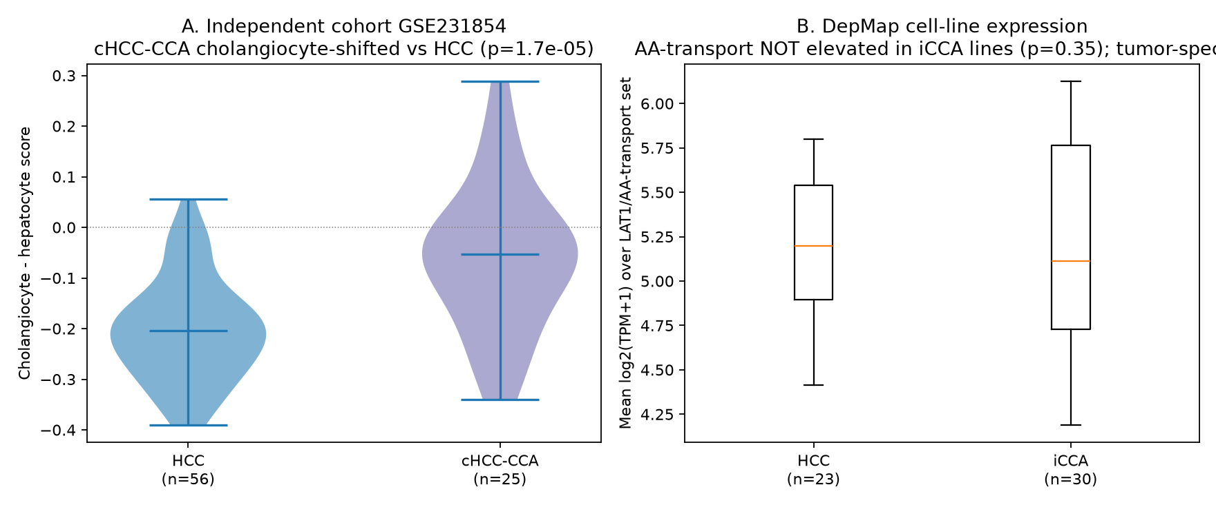
Figure 6. Ground-truth calibration of the anchor check. Using real TCGA-LIHC expression as substrate, a known 200-gene signature was spiked into a synthetic biological contrast, a synthetic batch effect was added to a synthetic cohort, and the aliasing of the contrast with the cohort was swept across 11 levels from 0 to 1 (20 repeats per level). Concordance is measured against a separate noisy orthogonal anchor (concordance to the truth only about 0.20), not the ground truth. Left: as aliasing increases, true-signal recall stays high (blue) while the false-discovery proportion rises to 0.93 (orange) and the noisy-anchor concordance shifts only modestly (dashed, 0.105 to 0.042). Right: pooling the 220 runs, the noisy-anchor concordance predicts the false-discovery proportion (Spearman -0.68, level-block bootstrap 95% CI -0.72 to -0.43; -0.68 under a multiplicative batch model). The within-level (alpha-conditioned) association is near zero (mean Spearman -0.02), and the anchor shares the injected signal with the recovered effect by construction, so the calibration reflects sensitivity to the aliasing regime, not an independent per-replicate association.
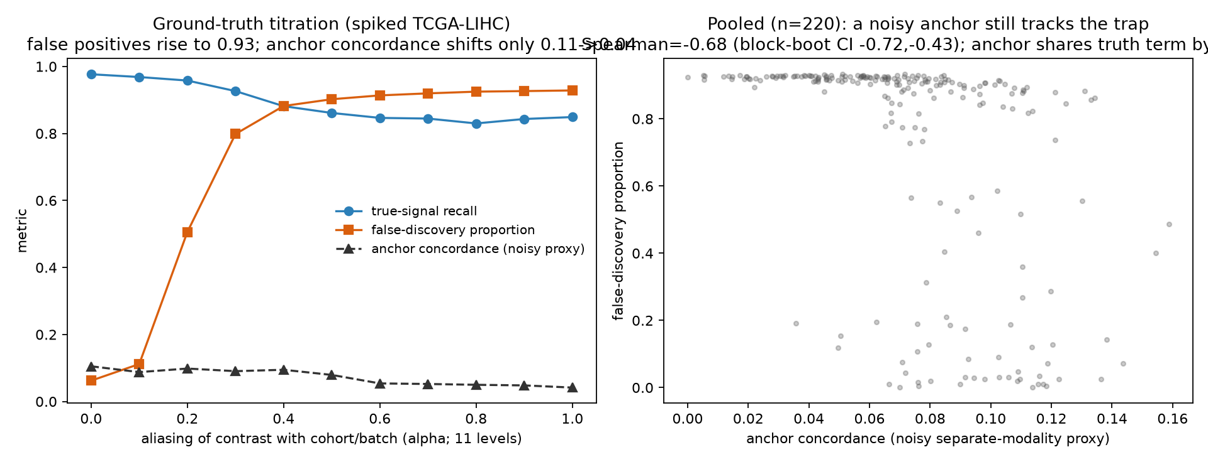

Tables
Table 1. Datasets used. All are public and openly downloadable.
Cohort | Source or accession | N used | Data type | Role
Gao 2019 HCC | NODE OEP000321 | 159 tumors | proteome, phosphosite | proteome and phospho
Dong 2022 iCCA | NODE OEP001105 | 214 proteome and phospho; 255 mRNA | proteome, phosphosite, mRNA | proteome and phospho
TCGA-LIHC | UCSC Xena GDC hub | 371 tumors | RNA-seq | batch-free lineage axis
TCGA-CHOL | UCSC Xena GDC hub | 35 tumors | RNA-seq | batch-free lineage axis
GSE241466 (i-CHC) | GEO | 8 i-CHC | RNA-seq | cHCC-CCA positioning
GSE231854 | GEO | 25 cHCC-CCA, 56 HCC | RNA-seq | independent cHCC-CCA replication
DepMap 24Q4 | figshare | 24 HCC, 31 iCCA lines | CRISPR Chronos and expression | dependency and line expression
ccRCC proteome | iProX IPX0001962000 (Qu 2022) | 232 tumors | proteome | kidney generality
pRCC proteome | PRIDE PXD013523 (Al Ahmad 2019) | 16 tumors | proteome | kidney generality
TCGA-KIRC, TCGA-KIRP | UCSC Xena GDC hub | 537, 290 tumors | RNA-seq | kidney batch-free anchor
OmniPath | Enzsub | 1,657 enzymes | kinase-substrate network | KSEA reference
Table 2. Genes passing the direct iCCA versus HCC dependency contrast (FDR below 0.1). Negative dChronos means more essential in iCCA lines. TFRC and TRPM7 remain pan-essential, so they are preferential rather than iCCA-exclusive. FDR reflects rank separation rather than effect magnitude, so NHEJ1 can show a low FDR despite a small dChronos; NHEJ1 has no transport rationale and is likely an incidental survivor.
Gene | dChronos (iCCA minus HCC) | FDR | Chronos iCCA | Chronos HCC | RNA log2FC (iCCA minus HCC)
TFRC | -0.548 | 0.063 | -0.989 | -0.441 | 0.642
TRPM7 | -0.521 | 0.075 | -1.052 | -0.531 | 0.633
SLC3A2 | -0.369 | 0.063 | -0.725 | -0.355 | 0.759
NHEJ1 | -0.159 | 0.045 | -0.171 | -0.012 | 0.460

References
- Gao Q, Zhu H, Dong L, et al. Integrated Proteogenomic Characterization of HBV-Related Hepatocellular Carcinoma. Cell 2019;179(2):561 to 577. (PMID 31585088)
- Dong L, Lu D, Chen R, et al. Proteogenomic characterization identifies clinically relevant subgroups of intrahepatic cholangiocarcinoma. Cancer Cell 2022;40(1):70 to 87. (PMID 34971568)
- Ally A, Balasundaram M, Carlsen R, et al. (TCGA). Comprehensive and Integrative Genomic Characterization of Hepatocellular Carcinoma. Cell 2017;169(7):1327 to 1341. (PMID 28622513)
- Farshidfar F, Zheng S, Gingras MC, et al. Integrative Genomic Analysis of Cholangiocarcinoma Identifies Distinct IDH-Mutant Molecular Profiles. Cell Reports 2017;18(11):2780 to 2794. (PMID 28297679)
- Goldman MJ, Craft B, Hastie M, et al. Visualizing and interpreting cancer genomics data via the Xena platform. Nature Biotechnology 2020;38(6):675 to 678. (PMID 32444850)
- Tsherniak A, Vazquez F, Montgomery PG, et al. Defining a Cancer Dependency Map. Cell 2017;170(3):564 to 576. (PMID 28753430)
- Dempster JM, Boyle I, Vazquez F, et al. Chronos: a cell population dynamics model of CRISPR experiments that improves inference of gene fitness effects. Genome Biology 2021;22(1):343. (PMID 34930405)
- Turei D, Korcsmaros T, Saez-Rodriguez J. OmniPath: guidelines and gateway for literature-curated signaling pathway resources. Nature Methods 2016;13(12):966 to 967. (PMID 27898060)
- Turei D, Valdeolivas A, Gul L, et al. Integrated intra- and intercellular signaling knowledge for multicellular omics analysis. Molecular Systems Biology 2021;17(3):e9923. (PMID 33749993)
- Casado P, Rodriguez-Prados JC, Cosulich SC, et al. Kinase-substrate enrichment analysis provides insights into the heterogeneity of signaling pathway activation in leukemia cells. Science Signaling 2013;6(268):rs6. (PMID 23532336)
- Wiredja DD, Koyuturk M, Chance MR. The KSEA App: a web-based tool for kinase activity inference from quantitative phosphoproteomics. Bioinformatics 2017;33(21):3489 to 3491. (PMID 28655153)
- Badia-i-Mompel P, Velez Santiago J, Braunger J, et al. decoupleR: ensemble of computational methods to infer biological activities from omics data. Bioinformatics Advances 2022;2(1):vbac016. (PMID 36699385)
- Johnson WE, Li C, Rabinovic A. Adjusting batch effects in microarray expression data using empirical Bayes methods. Biostatistics 2007;8(1):118 to 127. (PMID 16632515)
- Brunt E, Aishima S, Clavien PA, et al. cHCC-CCA: Consensus terminology for primary liver carcinomas with both hepatocytic and cholangiocytic differentiation. Hepatology 2018;68(1):113 to 126. (PMID 29360137)
- Abou-Alfa GK, Sahai V, Hollebecque A, et al. Pemigatinib for previously treated, locally advanced or metastatic cholangiocarcinoma with FGFR2 fusions or rearrangements (FIGHT-202). Lancet Oncology 2020;21(5):671 to 684. (PMID 32203698)
- Furuse J, Ikeda M, Ueno M, et al. A Phase II Placebo-Controlled Study of the Effect and Safety of Nanvuranlat in Patients with Advanced Biliary Tract Cancers Previously Treated by Systemic Chemotherapy. Clinical Cancer Research 2024;30(18):3990 to 3995. (PMID 39058429)
- Kaira K, Sunose Y, Arakawa K, et al. Clinical significance of L-type amino acid transporter 1 expression as a prognostic marker and potential of new targeting therapy in biliary tract cancer. BMC Cancer 2013;13:482. (PMID 24131658)
- Yanagisawa N, Ichinoe M, Mikami T, et al. High expression of L-type amino acid transporter 1 as a prognostic marker in bile duct adenocarcinomas. Cancer Medicine 2014;3(5):1246 to 1255. (PMID 24890221)
- Qu Y, Feng J, Wang Y, et al. A proteogenomic analysis of clear cell renal cell carcinoma in a Chinese population. Nature Communications 2022;13:2052. (PMID 35440542)
- Al Ahmad A, Paffrath V, Clima R, et al. Papillary Renal Cell Carcinomas Rewire Glutathione Metabolism and Are Deficient in Both Anabolic Glucose Synthesis and Oxidative Phosphorylation. Cancers 2019;11(9):1298. (PMID 31484429)
- Gagnon-Bartsch JA, Speed TP. Using control genes to correct for unwanted variation in microarray data. Biostatistics 2012;13(3):539 to 552. (PMID 22101192)
- Reese SE, Archer KJ, Therneau TM, et al. A new statistic for identifying batch effects in high-throughput genomic data using guided principal component analysis. Bioinformatics 2013;29(22):2877 to 2883. (PMID 23958724)
- Leek JT, Johnson WE, Parker HS, et al. The sva package for removing batch effects and other unwanted variation in high-throughput experiments. Bioinformatics 2012;28(6):882 to 883. (PMID 22257669)
- Zhang B, Wang J, Wang X, et al. Proteogenomic characterization of human colon and rectal cancer. Nature 2014;513(7518):382 to 387. (PMID 25043054)

